**Assignment 4: CIR (VIz)**

|  |  |  |
| --- | --- | --- |
| Name | Low Yang Tse | Lu Yang |
| Matriculation Number | A0124487Y | A0130684H |

1. **Introduction**

The objective of this assignment is to transform raw data into a form which can be visually interpreted and utilized by users in a fast and efficient manner. Furthermore, visualizing data may bring forth new findings which may not have otherwise been discovered. One such example is the discovery of patterns or trends.

For our team, we have successfully visualized the datasets according to the questions provided. Lu Yang was in charge of Parsing and Organizing the JSON datasets, while Yang Tse was in charge of creating the graphs using D3.js.

**2. Visualizations - Purpose & Method**

|  |  |
| --- | --- |
| Objective | Visualisation |
| 1 | Donut Chart |
| 2 | Donut Chart |
| 3 | Line Chart |
| 4 | Directed Force Graph |
| 5 | Line Chart |

(ii) Provide an image of each of the visualizations you created

Question 1: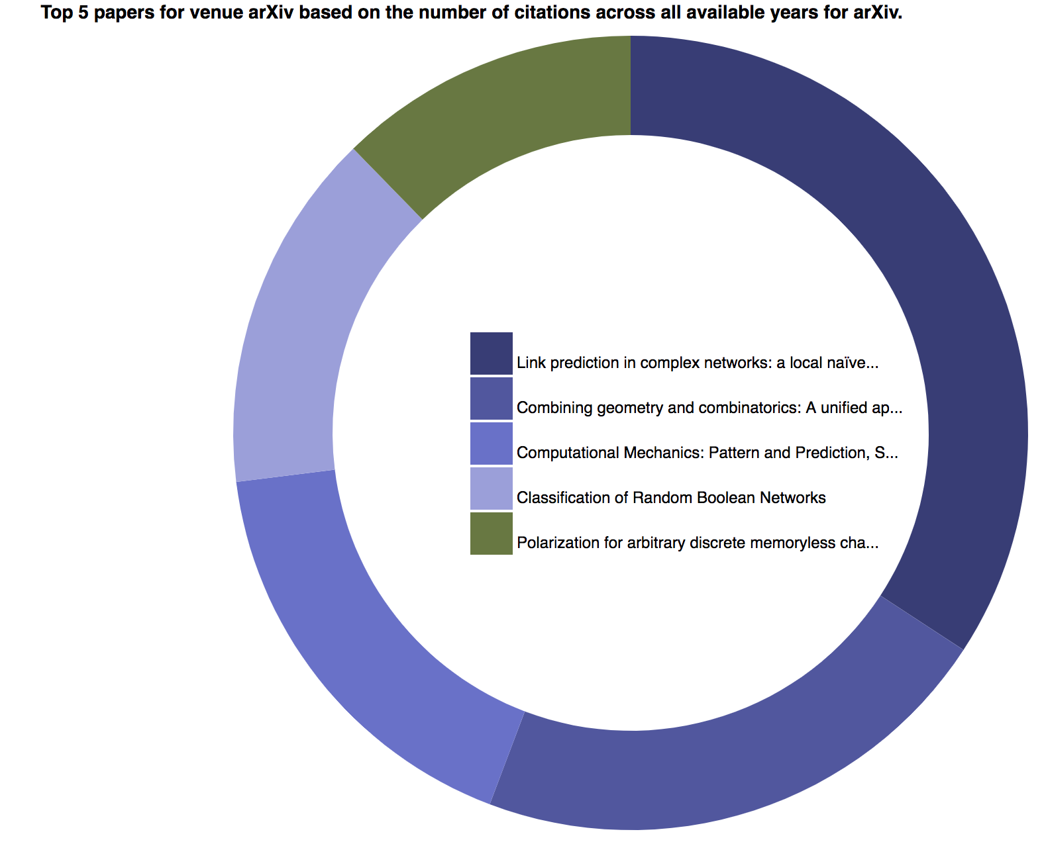

Question 2: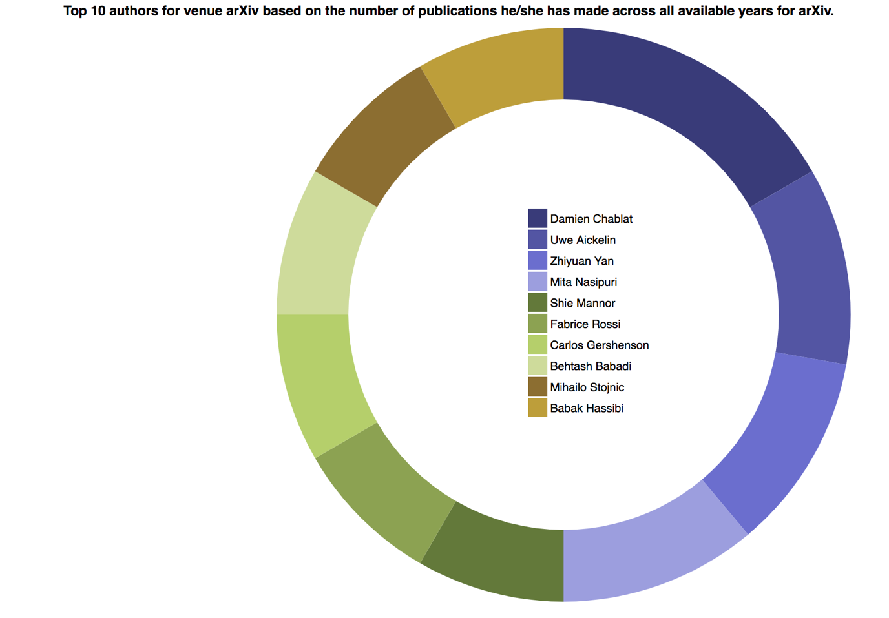

Question 3:

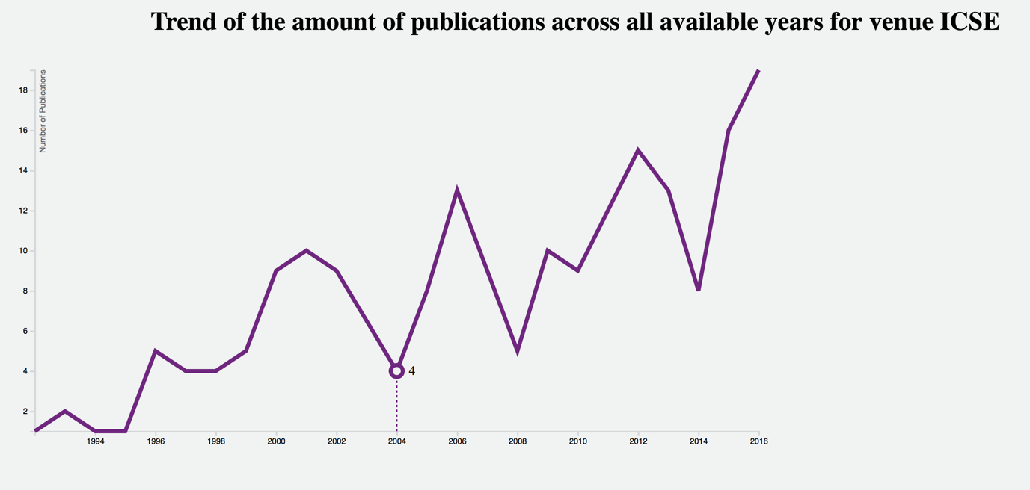

Question 4:

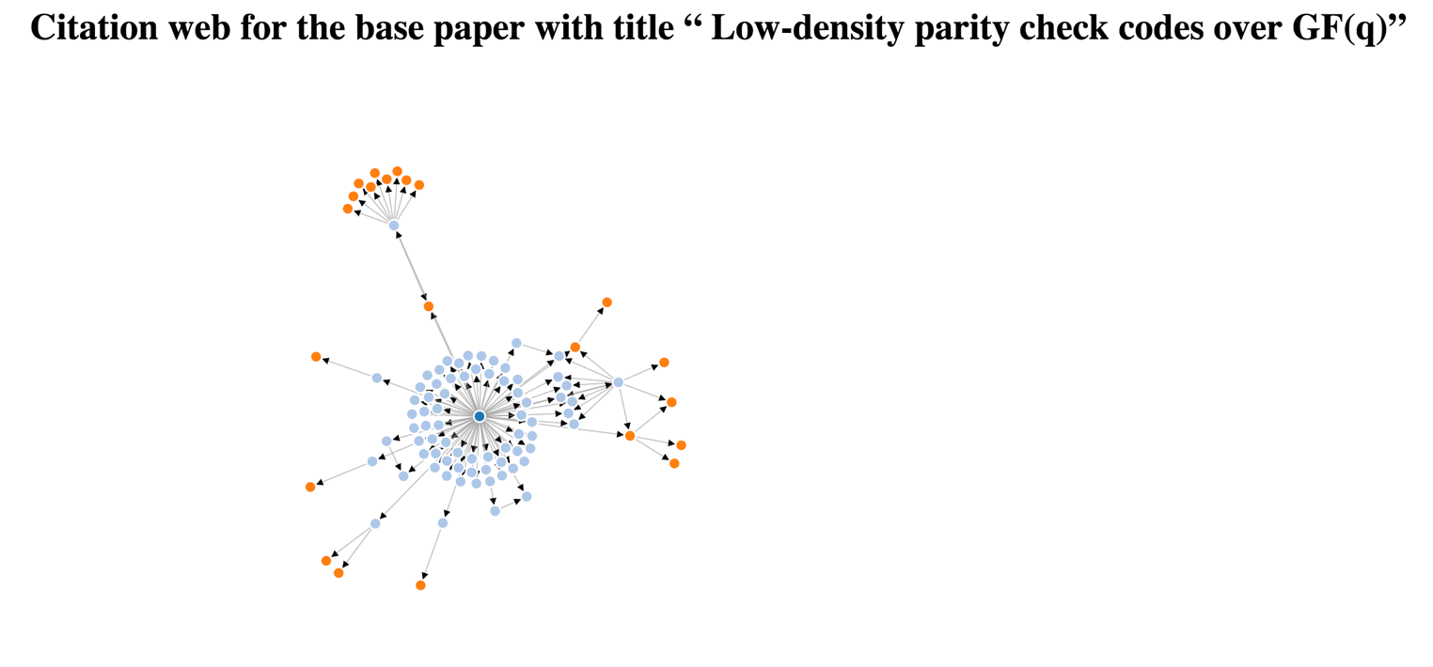

Question 5:

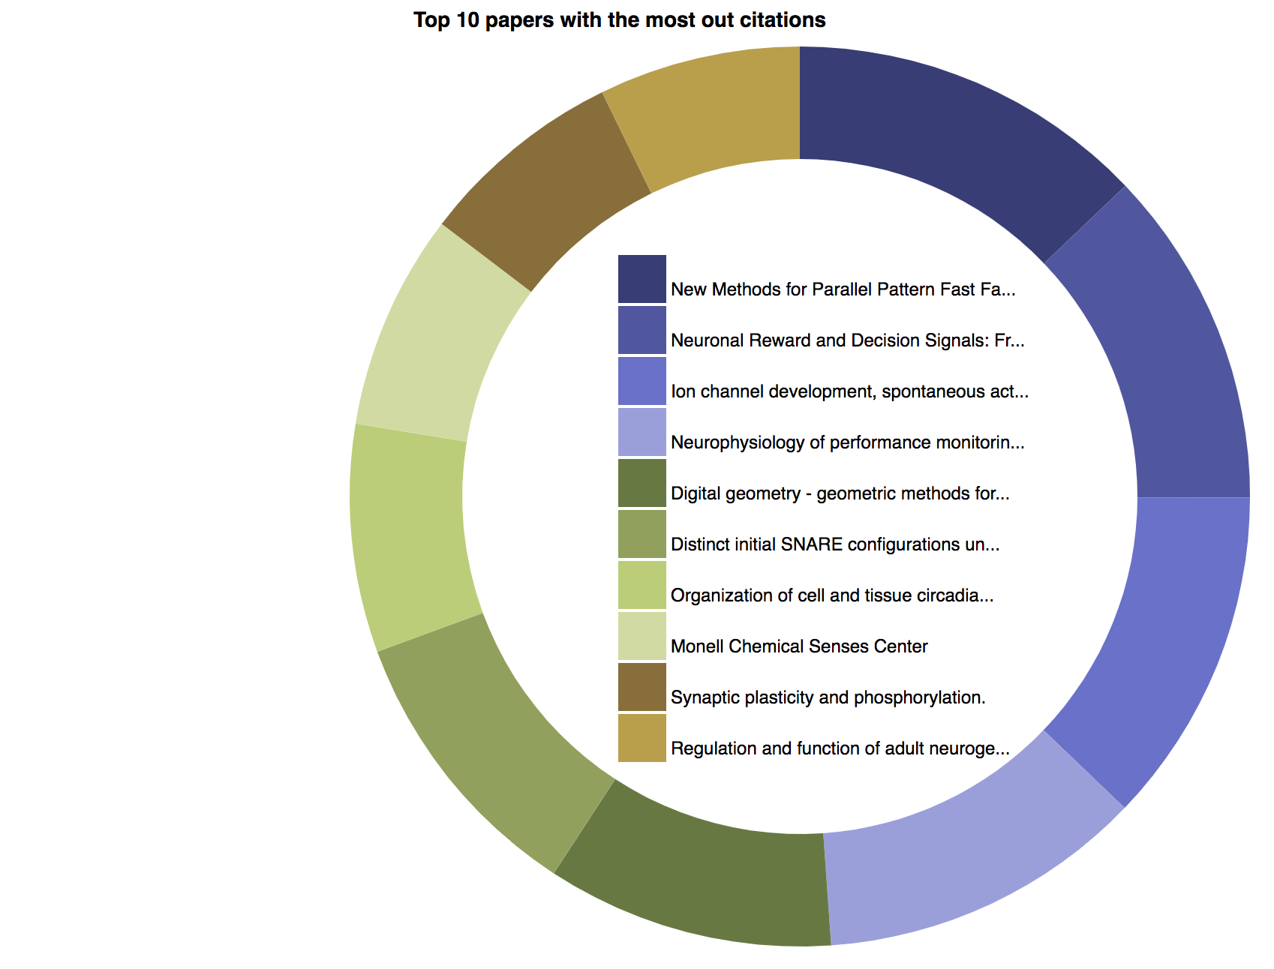

(iii) For any one of the visualizations:

Q1. Visualize the top 10 authors for venue arXiv based on the number of publications he/she has made across all available years for arXiv.

Parser

Pre-requisites.

* NodeJS.

Step 1: Run “$node server.js”. This command will execute the server script “server.js”. This file loads data from a JSON file named “data.json”, at the root directory of the project, and processes the data to find the top 10 authors for the venue “arXiv”. When that is done, the processed data will be stored as a javascript variable “topAuthors” in memory.

Step 2: After the parsing is completed, the server will automatically start listening to requests on port 8080. A user can navigate to <https://localhost:8080/q1> to view the D3 visualization. Behind the scene, the server is exposing a REST API endpoint at <https://localhost:8080/top_authors> for clients to retrieve data from the variable “topAuthors”. When the user navigates to <https://localhost:8080/q1> and view the HTML page, the client-side Javascript makes the HTTP get request to the endpoint, retrieves the data and render the data using client-side Javascript, HTML and CSS.

D3

Step 1: Draw Basic donut chart using D3.js as a script on html

Step 2: Implement legends to make the data more understandable and comprehensive and add in rectangles. As a legend

Step 3: Load in external data from JSON filed using D3.json

Step 4: Add tooltips for a more comprehensive visualisation of the data.

Step 5: Add animation for rectangles to toggle on and off different authors.